**CS544**

**Enterprise Architecture**

## Exam 1 April 2020

Name_________________________

Student ID ____________________________________

**NOTE: This material is private and confidential. It is the property of MUM and is not to be disseminated.**

1. ANSWER GOES HERE
2. Managed Beans can be injected in Spring. This excludes a POJO or JavaBean from ***ever***being injected.

False - A Java object can be a JavaBean, a POJO and a Spring bean all at the same time. So POJO, JavaBean also can injected in Spring.

1. The IoC container is exactly the same as Dependency Injection.

False – IOC is primary principle that create the objects, wire them together, configure them, and manage their complete life cycle from creation till destruction.. DI is one of type of IOC. So it is not exactly same.

1. For the following relationships implement a SubSelect that fetches all items with their corresponding collection of bids. The bid collection should be set as Lazy loaded.

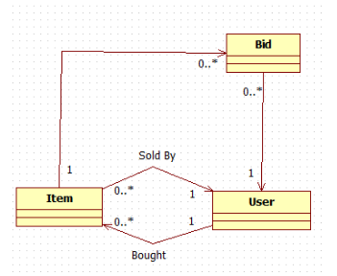What performance problem[s] does the SubSelect fetch address? What are its issues? How does it work? – Explain the “algorithm” based on a universe of 10 Items each with a collection of 5-10 Bids. Compare it to Join Fetch.

Answer :

1. Implement a parameterized JQPL query with this signature:

public List<Trip> findTripsbyDateAndPassengerCount(Integer passengerCount)

The query looks up Trip[s] that have a Booking associated with it that has more passengers than the parameterized count [passengerCount]. Also the Booking date must be the same as the Trip departure.

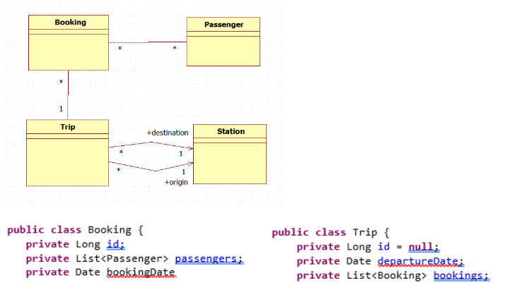

Answer:

1. Passengers.size > passengerCount
2. Booking.bookingDate =trip.departure

TripDaoImpl.java:

public List<Trip> findTripsbyDateAndPassengerCount(Integer passengerCount) {

Query q= entityManager.CreateQeury("select t from Trip t , Booking b where b.passengers.size >:pcount and b.bookingDate= t.departureDate");

return (List<Trip>) q.setParameter("pcount", passengerCount).getResultList();

}

TripService

public List<Trip> findTripsbyDateAndPassengerCount(Integer passengerCount);

TripService Impl

public List<Trip> findTripsbyDateAndPassengerCount(Integer passengerCount) {

return tripDao. findTripsbyDateAndPassengerCount(Integer passengerCount);

}

1. Explain the characteristics of an N-Tier Architecture. What is it for? When to Use? Be specif. Give examples.

